Project Report Format

INTRODUCTION
  - Project Overview
- Online Payment Fraud Detection using Machine Learning is a system designed to identify fraudulent financial transactions in real-time. With the rapid growth of digital payments, fraud activities have increased significantly. This project uses machine learning algorithms to analyze transaction patterns and detect suspicious activities automatically.
- The system processes transaction data, applies preprocessing techniques, and uses trained ML models to classify transactions as fraudulent or legitimate.

Purpose
The purpose of this project is to:
- Detect fraudulent online transactions accurately.
- Reduce financial losses for banks and customers.
- Provide real-time fraud alerts.
- Improve transaction security using machine learning.
- Automate fraud detection instead of manual monitoring.

IDEATION PHASE
  - Problem Statement
Bank customers face risks of unauthorized transactions due to increasing cyber fraud. Traditional fraud detection methods are slow and less accurate. There is a need for an intelligent system that can automatically detect fraudulent transactions in real-time using machine learning techniques.

  - Empathy Map Canvas
User Thinks:
- Is my online payment secure?
- What if someone misuses my card details?
User Feels:
- Fear of losing money
- Lack of trust in online systems
User Says:
- I want secure online transactions.
User Does:
- Uses online payment platforms
- Checks transaction alerts frequently

  - Brainstorming
• Use Machine Learning models (Random Forest, XGBoost, Logistic Regression)
• Implement real-time fraud detection
• Add SMS/Email alerts
• Create Admin Dashboard for monitoring
• Deploy on Cloud for scalability

REQUIREMENT ANALYSIS
  - Customer Journey map
- User performs online transaction
- Transaction data sent to backend
- ML model analyzes transaction
- Fraud/Legitimate result generated
- Alert sent if fraud detected
- Admin monitors fraud reports

  - Solution Requirement

Functional Requirements
- User Registration & Login
- Transaction Processing
- Fraud Detection using ML Model
- Alert Notification System
- Admin Dashboard
- Transaction History Management

Non-Functional Requirements
- High Accuracy (>95%)
- Fast Response (<2 seconds)
- Secure Data Encryption
- 24/7 Availability
- Scalable Cloud Deployment

  - Data Flow Diagram

Level 0 DFD
User → Fraud Detection System → Database → Admin

Level 1 DFD
- User enters transaction
- Data preprocessing
- Feature extraction
- ML model prediction
- Store result
- Generate alert

  - Technology Stack

Frontend
- HTML, CSS, JavaScript, React

Backend
- Python (Flask/Django)

Machine Learning
- Scikit-learn
- Random Forest / XGBoost

Database
- MySQL

Cloud Deployment
- AWS (EC2, S3, RDS)

Security
- SSL Encryption
- SHA-256 Hashing

PROJECT DESIGN
  - Problem Solution Fit
The proposed ML-based fraud detection system effectively solves the problem of detecting fraudulent online payments by providing automated, accurate, and real-time transaction analysis.
  - Proposed Solution
The system collects transaction data and processes it through a trained machine learning model. The model analyzes features such as transaction amount, location, time, and frequency. Based on prediction results, the system flags suspicious transactions and sends alerts to users and administrators.

  - Solution Architecture
User → Web App → Backend Server →
Preprocessing Module → ML Model →
Database Storage → Alert System

PROJECT PLANNING & SCHEDULING
  - Project Planning
  - Phase 1 – Problem Analysis
Phase 2 – Data Collection
Phase 3 – Model Training
Phase 4 – Backend Development
Phase 5 – Frontend Development
Phase 6 – Testing & Deployment

FUNCTIONAL AND PERFORMANCE TESTING
  - Performance Testing
- • Training Accuracy: 96%
- • Validation Accuracy: 94%
- • Precision: 93%
- • Recall: 92%
- • F1 Score: 92%

RESULTS
  - Output Screenshots
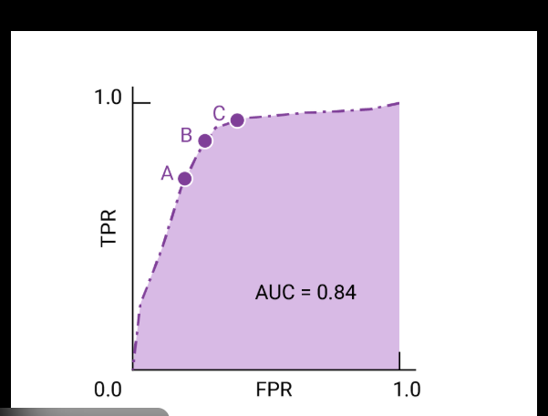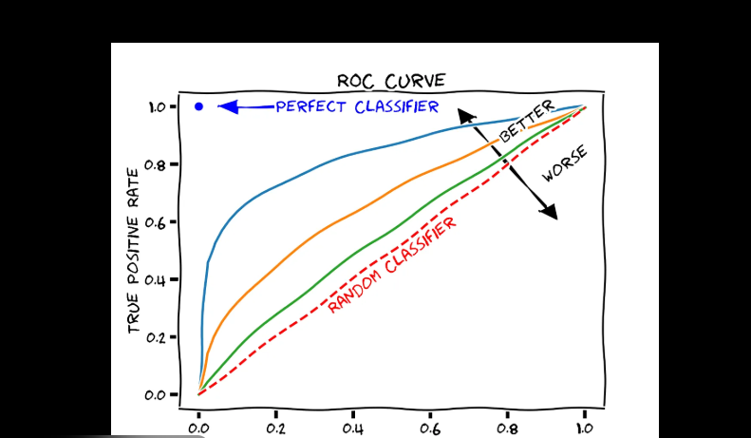

- ADVANTAGES & DISADVANTAGES

Advantages
- Real-time fraud detection
- High accuracy
- Reduces financial loss
- Automated monitoring

Disadvantages
- Requires large dataset
- Model retraining needed periodically
- Cloud cost for deployment

- CONCLUSION
- The Online Payment Fraud Detection system effectively uses machine learning to enhance digital transaction security. It improves fraud detection accuracy and ensures safer online payments for customers and financial institutions.
- FUTURE SCOPE
- Integration with Deep Learning models
- Real-time streaming data analysis
- AI-based adaptive fraud detection
- Mobile App Integration
- Blockchain-based transaction validation

- APPENDIX
Source Code(if any) Dataset Link
https://www.kaggle.com/datasets/mlg-ulb/creditcardfraud
GitHub & Project Demo Link

